Syracuse Chargers
All Comers / All Ages Summer Track & Field Meet 2023
Meet #2 @ Fulton HS - Thu August 10th
^{FREE! – Sign up on site!}
Registration: 5:00–5:30pm – 5:30pm start
Order of events:
HH (14+ ONLY = 100m or 110m) – Hurdlers MUST be willing to set up & take down hurdles in order to compete!
100m 1500 200m 200H 800m 3000m Long Jump / Triple Jump

High Jump & Pole Vault - Tentative:
These two events will ONLY be held if the competitors involved arrive at 4:30 to set up and move the mats themselves, under the direction of the Chargers and approved by the officials. Those competitors MUST also stay to take them down after the meet. If there are NOT enough competitors to do so…these events will be cancelled.
* Vaulters must bring their own certified poles. The Chargers will NOT provide them.

Shot Put / Discus / Javelin
*Throwers must bring their own age-appropriate implements. The Chargers will NOT provide them. Throwers must have
basic competency and experience in order to throw. This is a competition…not a clinic.

If you already filled a waiver out at our last meet (Clinton) you do NOT need to do so again (You DO need to do Track event cards)

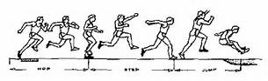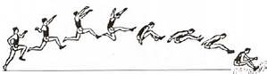

Name____________________________________________________________________________________M_____F____ Age_________

Club/School______________________________________________________________________ Date of Birth___________________________

Home Address (Street) _________________________________________________________________________________________________

City, State, Zip _______________________________________________________________________________________________________

Phone #__________________________________Guardian’s address (if different from above):_____________________________________

Emergency contact_______________________________________ Emergency contact phone # ___________________________________

Waiver: In consideration of this entry, I, the undersigned, intending to be legally bound hereby, for myself, my heirs and executors, and administrators, waive and release any and all rights and claims for damages I may have against the Syracuse Chargers Track Club Inc., Onondaga Enterprises, the Road Runners Club of America and all other sponsors and their representatives. I attest and verify that I am physically fit and have sufficiently trained for these events. I am aware that medical support for these meets will be volunteers who will be prepared to administer first aid assistance only. I grant permission to use for legitimate purposes any photographs, motion pictures, recordings, or other images of myself participating in these meets.
I hereby certify that I have read all the terms and conditions of this release and intend to be legally bound thereby. 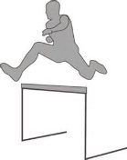
Signature of Participant:
__________________________________________________Date:_____________

__________________________________________________Date:_____________
(Signature of parent or guardian for all participants age 17 or younger.)

